WEB DESIGN 1
2ndSemester SY 2025-2026
SCORE

Name: Alviar, Arwen Fae P. Date: 03/05/2025
Course and Year: ACT-MM1 Section: ICA1
OUTPUT:
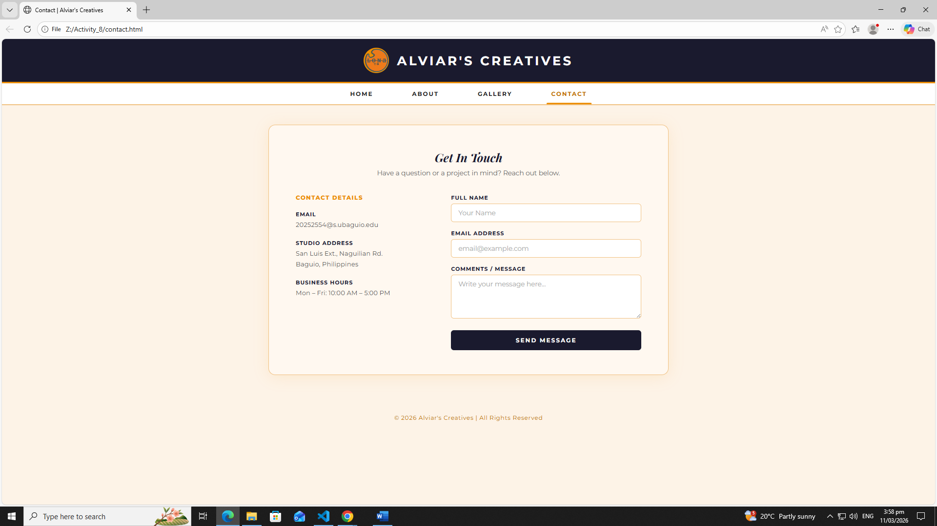

CODE contact:
<!DOCTYPE html>
<html lang="en">
<head>
<meta charset="UTF-8" />
<meta name="viewport" content="width=device-width, initial-scale=1.0"/>
<title>Contact | Alviar's Creatives</title>
<link href="https://fonts.googleapis.com/css2?family=Playfair+Display:ital,wght@0,700;1,700&family=Montserrat:wght@400;600;700;800&family=Lato:ital,wght@0,400;1,400&display=swap" rel="stylesheet"/>
<link rel="stylesheet" href="style.css"/>
</head>
<body>

<header>
<div class="logo-icon">
<img src="LONA-Transparent.png" alt="Alviar Creatives Logo">
</div>
<h1>Alviar's Creatives</h1>
</header>

<nav>
<a href="index.html">Home</a>
<a href="about.html">About</a>
<a href="gallery.html">Gallery</a>
<a href="contact.html" class="active">Contact</a>
</nav>

<div class="wrapper">
<div class="card contact-card">
<div class="card-header">
<h2>Get In Touch</h2>
<p>Have a question or a project in mind? Reach out below.</p>
</div>
<div class="two-col">
<div class="contact-details">
<h3>Contact Details</h3>
<div class="detail-block">
<div class="label">Email</div>
<div class="value">20252554@s.ubaguio.edu</div>
</div>
<div class="detail-block">
<div class="label">Studio Address</div>
<div class="value">San Luis Ext., Naguilian Rd.<br>Baguio, Philippines</div>
</div>
<div class="detail-block">
<div class="label">Business Hours</div>
<div class="value">Mon – Fri: 10:00 AM – 5:00 PM</div>
</div>
</div>
<div class="contact-form">
<div class="form-group">
<label>Full Name</label>
<input type="text" placeholder="Your Name" />
</div>
<div class="form-group">
<label>Email Address</label>
<input type="email" placeholder="email@example.com" />
</div>
<div class="form-group">
<label>Comments / Message</label>
<textarea placeholder="Write your message here..."></textarea>
</div>
<button class="btn-send">Send Message</button>
</div>
</div>
</div>
</div>

<footer>© 2026 Alviar's Creatives | All Rights Reserved</footer>

</body>
</html>

REFLECTION:

- Why is it important to use clear labels and placeholders in a web form?
  - They provide clarity and context. Labels tell the user exactly what data is needed, while placeholders offer a visual hint or example of the format, making the form easier to fill out and reducing errors.

- How does a two-column layout help in organizing different types of related information on a single page?
  - They help categorize content. By separating primary information from secondary details (like putting a bio on one side and a project list on the other), you create a balanced page that is easier for the eye to scan and digest.

